**ZEN PORTAL SAMPLE DESIGN BY USING MY SQL**

**DIAGRAM**

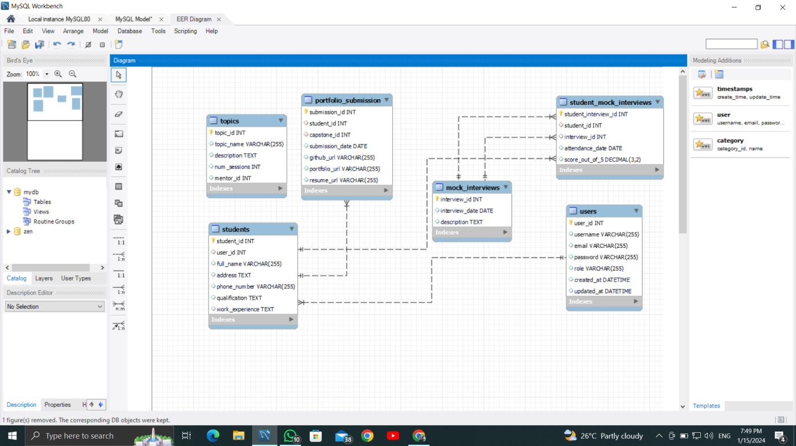

**ZEN PORTAL SAMPLE DESIGN BY USING MY SQL**

**CODE**

create database zen;

use zen;

create table users(

`user_id` INT PRIMARY KEY,

`username` VARCHAR(255),

`email` VARCHAR(255),

`password` VARCHAR(255),

`role` VARCHAR(255),

`created_at` DATETIME DEFAULT (CURRENT_TIMESTAMP),

`updated_at` DATETIME

);

CREATE TABLE `students` (

`student_id` INT PRIMARY KEY,

`user_id` INT,

`full_name` VARCHAR(255),

`address` TEXT,

`phone_number` VARCHAR(255),

`qualification` TEXT,

`work_experience` TEXT

);

CREATE TABLE `mentors` (

`mentor_id` INT PRIMARY KEY,

`user_id` INT,

`full_name` VARCHAR(255),

`address` TEXT,

`phone_number` VARCHAR(255),

`qualification` TEXT,

`work_experience` TEXT

);

CREATE TABLE `topics` (

`topic_id` INT PRIMARY KEY,

`topic_name` VARCHAR(255),

`description` TEXT,

`num_sessions` INT,

`mentor_id` INT

);

CREATE TABLE `tasks` (

`task_id` INT PRIMARY KEY,

`topic_id` INT,

`task_name` VARCHAR(255),

`description` TEXT,

`deadline` DATE

);

CREATE TABLE `attendance` (

`attendance_id` INT PRIMARY KEY,

`user_id` INT,

`topic_id` INT,

`session_date` DATE,

`status` VARCHAR(255)

);

CREATE TABLE `company_drive` (

`drive_id` INT PRIMARY KEY,

`company_name` VARCHAR(255),

`drive_date` DATE,

`description` TEXT

);

CREATE TABLE `user_company_drive_attendance` (

`user_drive_attendance_id` INT PRIMARY KEY,

`user_id` INT,

`drive_id` INT

);

CREATE TABLE `capstone` (

`capstone_id` INT PRIMARY KEY,

`user_id` INT,

`project_name` VARCHAR(255),

`description` TEXT

);

CREATE TABLE `queries` (

`query_id` INT PRIMARY KEY,

`student_id` INT,

`mentor_id` INT,

`topic_id` INT,

`question` TEXT,

`answer` TEXT

);

CREATE TABLE `portfolio_submission` (

`submission_id` INT PRIMARY KEY,

`student_id` INT,

`capstone_id` INT,

`submission_date` DATE,

`github_url` VARCHAR(255),

`portfolio_url` VARCHAR(255),

`resume_url` VARCHAR(255)

);

CREATE TABLE `mock_interviews` (

`interview_id` INT PRIMARY KEY,

`interview_date` DATE,

`description` TEXT

);

CREATE TABLE `student_mock_interviews` (

`student_interview_id` INT PRIMARY KEY,

`student_id` INT,

`interview_id` INT,

`attendance_date` DATE,

`score_out_of_5` DECIMAL(3, 2)

);

ALTER TABLE `students` ADD FOREIGN KEY (`user_id`) REFERENCES `users` (`user_id`);

ALTER TABLE `mentors` ADD FOREIGN KEY (`user_id`) REFERENCES `users` (`user_id`);

ALTER TABLE `topics` ADD FOREIGN KEY (`mentor_id`) REFERENCES `mentors` (`mentor_id`);

ALTER TABLE `tasks` ADD FOREIGN KEY (`topic_id`) REFERENCES `topics` (`topic_id`);

ALTER TABLE `attendance` ADD FOREIGN KEY (`user_id`) REFERENCES `users` (`user_id`);

ALTER TABLE `attendance` ADD FOREIGN KEY (`topic_id`) REFERENCES `topics` (`topic_id`);

ALTER TABLE `user_company_drive_attendance` ADD FOREIGN KEY (`user_id`) REFERENCES `users` (`user_id`);

ALTER TABLE `user_company_drive_attendance` ADD FOREIGN KEY (`drive_id`) REFERENCES `company_drive` (`drive_id`);

ALTER TABLE `capstone` ADD FOREIGN KEY (`user_id`) REFERENCES `users` (`user_id`);

ALTER TABLE `queries` ADD FOREIGN KEY (`student_id`) REFERENCES `students` (`student_id`);

ALTER TABLE `queries` ADD FOREIGN KEY (`mentor_id`) REFERENCES `mentors` (`mentor_id`);

ALTER TABLE `queries` ADD FOREIGN KEY (`topic_id`) REFERENCES `topics` (`topic_id`);

ALTER TABLE `portfolio_submission` ADD FOREIGN KEY (`student_id`) REFERENCES `students` (`student_id`);

ALTER TABLE `portfolio_submission` ADD FOREIGN KEY (`capstone_id`) REFERENCES `capstone` (`capstone_id`);

ALTER TABLE `student_mock_interviews` ADD FOREIGN KEY (`student_id`) REFERENCES `students` (`student_id`);

ALTER TABLE `student_mock_interviews` ADD FOREIGN KEY (`interview_id`) REFERENCES `mock_interviews` (`interview_id`);